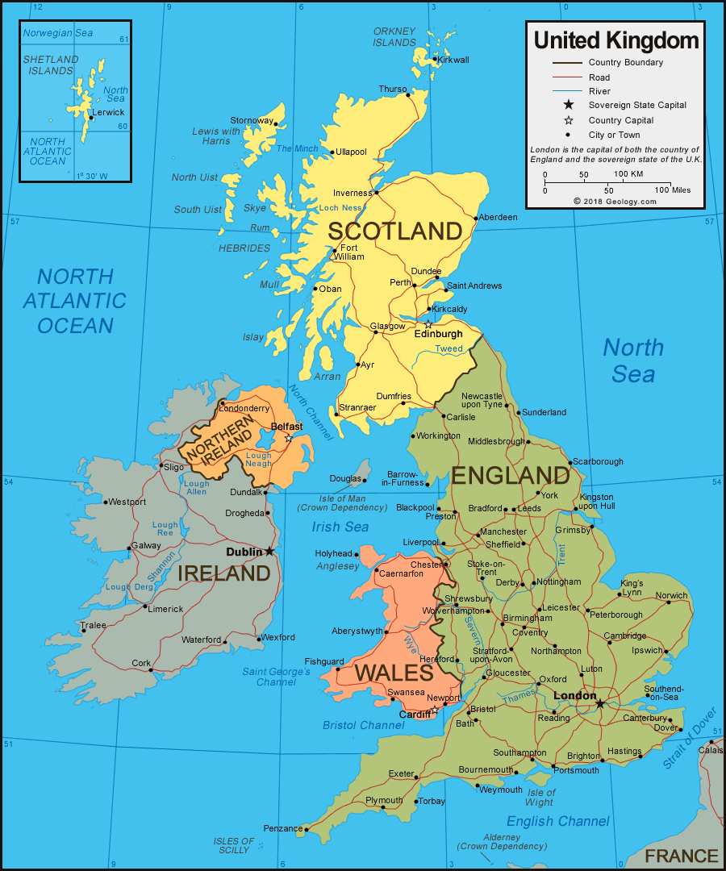
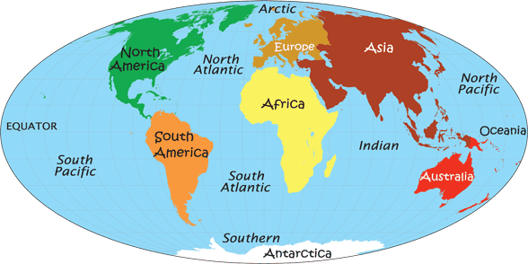
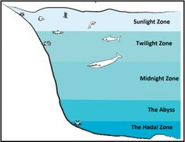
Blue Abyss – Seas and Oceans
Key Knowledge
There are 5 oceans in the world: Pacific, Atlantic, Southern, Arctic and Indian
There are lots of seas in the world. Around Britain, the closest seas are the Irish Sea, the North Sea and the English Channel
Oceans have 5 zones – daylight, twilight, midnight and abyssal zones. Different animals can be found in each of these zones.
Sea creatures have adapted to live in different zones of the ocean, and in different types of habitats.
Ocean habitats and wildlife are being damaged by climate change and pollution
Key Vocabulary
Ocean – large and deep bodies of water, that join together to make one continuous body of water.
Sea – smaller and shallower bodies of water between countries.
Pollution – waste that has been introduced into an environment that is harmful
Tide – rise and fall of the sea as it reaches the land, usually twice a day
Current – constant movement of sea water
Climate – the usual weather in any particular area
Equator – the imaginary line around the widest point of the earth
Tropic of cancer/Capricorn – lines on the globe that mark the tropical areas around the equator
Key Text
Song of the Dolphin Boy
